ARM

Tom Goncin
How to Build Keil Project 4
Setting Up Your ARM File 6
Processor Register Status Condition Bit Flags 7
Registers 8
Main Instruction Mnemonics (ARM, Keil µVision context) 8
Transferring Data from Memory to a Register 9
Program Counter 10
Stack 10
Link Register 11
TST – ARM “Test” Instruction 11
BEQ – Branch if Equal 12
B – Branch 13
What B does: It performs an unconditional branch (jump) to a specified label or address. Execution continues at the target address. It is used to change the program flow unconditionally. 13
Syntax: 13
B label 13
label: The target address or label to branch to. 13
Typical usage: 13
• Jump to a loop start or another part of the code. 13
• Jump unconditionally to a subroutine or error handler without linking (no return address saved). 13
Example: 13
B LoopStart 13
;Jump to label LoopStart 13
BL – Branch with Link 13
What BL does: It performs a branch (jump) to a subroutine and saves the return address (address of the next instruction) into the Link Register (LR). This enables subroutine calls with return. 13
Syntax: 13
BL label 13
label: The subroutine address or label. 13
Typical usage: 13
• Call a subroutine or function. 13
• The called routine returns by branching to the return address stored in LR, typically using BX LR. 13
Example: 13
BL Subroutine 13
; Call the subroutine 'Subroutine' 13
AND – bitwise AND 15
Bx – Branch & Exchange 16
BIC – Bit Clear 17
ORR – bitwise OR 18
Nested Subroutine 19

How to Build Keil Project
Steps to Run
- Save:

  - Save the file as nzcv_flags.s in your Keil µVision project folder.

- Build Target:

  - In Keil µVision, go to Project > Build Target (or press F7)
  - Check the Build Output window for errors (e.g., syntax errors, undefined symbols)
Correct any issues (e.g., missing labels, incorrect syntax)

- Download and Debug:

  - Go to Debug > Start/Stop Debug Session (or press Ctrl + F5).
  - Use the debugger to step through (F11), monitor registers (R0, R1, R2), and check NZCV flags in the Register window.
  - Verify results match the expected values and flag states.

- IF YOUR ONLY SIMULATING

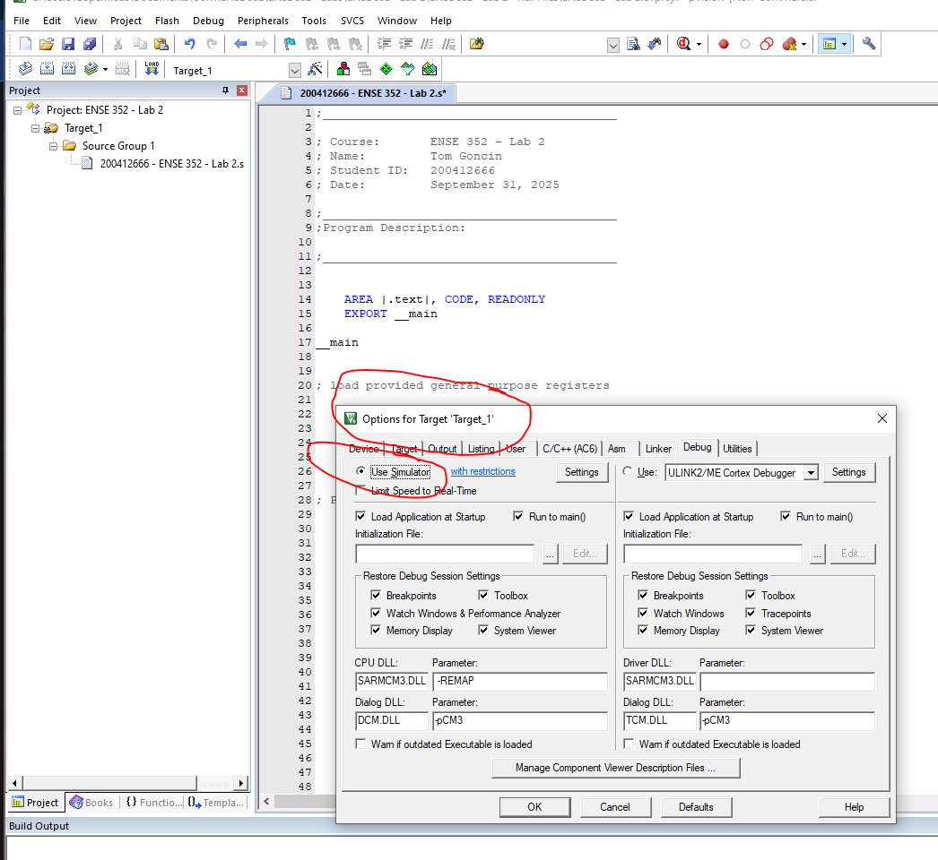

Setting Up Your ARM File
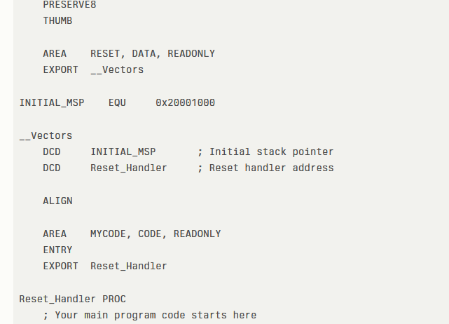

 | Syntax | Purpose
PRESERVE8 |  |  | Ensures 8-byte stack alignment per ARM calling convention, required on Cortex-M cores.
THUMB |  |  | Assembles code in Thumb instruction set (16-bit), mandatory for Cortex-M processors.
AREA RESET, DATA, READONLY |  |  | Defines a read-only data section named RESET, typically holds the interrupt vector table.
EXPORT __Vectors |  |  | Makes the __Vectors symbol globally accessible for linker/vector table reference.
INITIAL_MSP EQU 0x20001000 |  |  | Defines a constant for initial Main Stack Pointer address at top of RAM (example value).
__Vectors |  |  | Label marking start of the vector table, at flash start, containing stack pointer and reset handler addresses.
DCD INITIAL_MSP |  |  | Places initial MSP value at vector table start, to load into MSP on reset.
DCD Reset_Handler |  |  | Places address of Reset_Handler in vector table, CPU execution starts here after reset.
ALIGN |  |  | Ensures following data/code is 4-byte aligned to meet CPU fetch and memory alignment rules.
AREA MYCODE, CODE, READONLY |  |  | Declares a new read-only code section named MYCODE for program instructions and subroutines.
ENTRY |  |  | Marks the start address of the program (entry point symbol) for the linker and debugger.
EXPORT Reset_Handler |  |  | Makes Reset_Handler accessible for vector table and linker.
Reset_Handler PROC |  |  | Begins the definition of Reset_Handler function, the CPU reset entry routine.

Processor Register Status Condition Bit Flags

Flag | Name | What it means
N | Negative | Result is negative (most significant bit set)
Z | Zero | Result is zero
C | Carry | Unsigned overflow/carry
V | Overflow | Signed overflow

Flag | = 0 | = 1
Z  (Zero) | If the result is non-zero | If the result of an operation is exactly zero  (all bits = 0)
N  (Negative) | if the result is positive  (most significant bit = 0) | if the result is negative  (most significant bit of the result is 1)
C  (Carry) | if there was no carry/borrow  —i.e., the operation completed within the bit-width | if there was a carry out from the most significant bit (unsigned overflow on addition), or a borrow out on subtraction
V  (Overflow) | if there was no signed overflow, meaning the result fits in the signed range.​  For an 8-bit signed number, the range is from  $-128$to $+127$.  For a 4-bit signed number, the range is from  $-8$to $+7$. | if the result caused a signed overflow  (result can't be represented within the signed range of the register, e.g., adding two positives yields a negative, or two negatives yield a positive)

Registers
Register | Usage
R0–R12 | General-purpose
R13 | Stack Pointer (SP)
R14 | Link Register (LR)
R15 | Program Counter (PC)
APSR | Application PSR (Status)
IPSR | Interrupt PSR
EPSR | Execution PSR
CPSR | Current PSR (Status)
SPSR | Saved PSR (Status)

Main Instruction Mnemonics
(ARM, Keil µVision context)

Register | Usage
- LDR (Load Register)  - STR (Store Register)  - ADD (Add)  - SUB (Subtract)  - ADDS (Add and set status flags)  - SUBS (Subtract and set status flags)  - MOV (Move value/register)  - CMP (Compare, updates status flags)  - AND (Bitwise AND)  - ORR (Bitwise OR)  - EOR (Bitwise Exclusive OR)  - B (Branch) | - BL (Branch with Link - function call)  - BX (Branch and Exchange)  - PUSH (Push register(s) onto stack)  - POP (Pop register(s) from stack)  - MUL (Multiply)  - MVN (Move NOT - Bitwise NOT)  - LSL (Logical Shift Left)  - LSR (Logical Shift Right)  - ROR (Rotate Right)  - TST (Test bitwise AND)  - TEQ (Test bitwise EOR)  - BIC (Bit clear)

Transferring Data from Memory to a Register

op{type}{cond} Rt, [Rn {, #offset}] ; Immediate offset

Where,
- ‘op’ is either LDR (load register) or STR (store register)
- ‘type’ is one of the following:
- B: Unsigned byte, zero extends to 32 bits on loads
- SB: Signed byte, sign extends to 32 bits (LDR only)
- H: Unsigned halfword, zero extends to 32 bits on loads
- SH: Signed halfword, sign extends to 32 bits (LDR only)
- ‘cond’ is an optional condition code (see Conditional execution on page 58)
- ‘Rt’ is the register to load or store
- ‘Rn’ is the register on which the memory address is based‘offset’ is an offset from Rn. If offset is omitted, the address is the contents of Rn

Program Counter

Program Counter - R15
- The Program Counter is a register that contains the address of the current instruction.
- During normal logical flow the Program Counter increments according to the instructions implemented in order.
- After a branch or subroutine call the Program Counter will contain the “jumped to “ address.
- You are able to access this register from your code by using R15 or PC.

Stack
The Stack  - Remember the stack pointer (R13) points to the top of stack.  - A typical stack is an area of computer memory with a fixed origin and a variable size.  - A stack pointer, usually in the form of a hardware register, points to the most recently referenced location on the stack  - A stack is used to hold information as your program runs.  - It is also used to:  - Keep track of where you were during a branch or sub routine call.  - Pass parameters to subroutines.  - Anything you would like saved.  - The two operations applicable to all stacks are: | 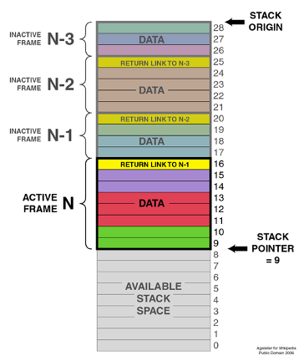
  - A push operation:

In which a data item is placed at the location pointed to by the stack pointer, and the address in the stack pointer is adjusted by the size of the data item.
Push {R1} or Push{R1,R2,R3}
  - A pop or pull operation:

A data item at the current location pointed to by the stack pointer is removed, and the stack pointer is adjusted by the size of the data item.
Pop {R1} or Pop{R1,R2,R3}

Link Register

Holds the address of code that you want to store to come back to.

TST – ARM “Test” Instruction

Performs a bitwise AND operation between:
the first operand (register) and
the second operand (immediate or register)
BUT
does not store the result.
Instead,
it updates the CPU's condition flags (such as Zero flag) based on the result of the AND.

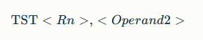
Breakdown:
TST
The mnemonic for the "Test" instruction, which performs a bitwise AND between the contents of register $Rn$and an operand but does not change the register values.
<Rn>
The first register operand, which contains the value to be tested.
<Operand2>
The second operand, which can be:
  - An immediate value (usually prefixed with #),
  - A register,
  - A shifted register value.

BEQ – Branch if Equal

What BEQ does:
It causes the program to jump (branch) to a specified label or address if the Zero (Z) flag is set.
The Zero flag is typically set after a previous comparison or test instruction if the comparison indicates equality (e.g., two values are equal or a tested value is zero).

BEQ <label>
BEQ
The mnemonic for branch-if-equal.
<label>
The target location (a label defined elsewhere in the code) to jump to if the condition is true.
How it works:
- After an instruction like CMP or TST that updates the condition flags,
- If the Zero flag is set (Z = 1), the processor jumps to <label>.
- If Z is not set (Z = 0), execution continues sequentially.

B – Branch

What B does:
It performs an unconditional branch (jump) to a specified label or address. Execution continues at the target address. It is used to change the program flow unconditionally.

Syntax:

B label

label: The target address or label to branch to.

Typical usage:

Jump to a loop start or another part of the code.

Jump unconditionally to a subroutine or error handler without linking (no return address saved).

Example:

B LoopStart

;Jump to label LoopStart

BL – Branch with Link

What BL does:
It performs a branch (jump) to a subroutine and saves the return address (address of the next instruction) into the Link Register (LR). This enables subroutine calls with return.

Syntax:

BL label

label: The subroutine address or label.

Typical usage:

Call a subroutine or function.

The called routine returns by branching to the return address stored in LR, typically using BX LR.

Example:

BL Subroutine

; Call the subroutine 'Subroutine'

AND – bitwise AND

The ARM AND instruction performs a bitwise AND operation between two operands and stores the result in the destination register.

What AND does:
- It compares each bit of the first operand with the corresponding bit of the second operand.
- The resulting bit is 1 only if both bits are 1.
- Otherwise, the resulting bit is 0.

Syntax:
AND Rd, Rn, Operand2

- Rd: Destination register where the result is stored.
- Rn: First source register.
- Operand2: Second operand (register, immediate, or shifted register).

Example:
AND R0, R1, #0xFF
R0 = R1 AND 0xFF, mask low 8 bits of R1
AND R2, R3, R4
R2 = R3 AND R4, bitwise AND of two registers

Use Cases:
- Masking bits (keeping some bits and clearing others).
- Checking specific bits by ANDing with a mask.
- Bitwise logical operations for flags, control bits, or bit fields.
In C, this is equivalent to:
$$Rd=Rn\&Operand2$$
The AND instruction is fundamental for bit manipulation in ARM assembly programming.

Bx – Branch & Exchange

What BX does:
- It performs an indirect branch to the address contained in a register.
- The instruction copies the value of the specified register into the Program Counter (PC), causing a jump to that address.
- It also examines the least significant bit (bit 0) of the address to determine the processor state:
  - If bit 0 is 0, the processor continues in ARM state.
  - If bit 0 is 1, the processor switches to Thumb state.
- This makes BX useful for switching between ARM and Thumb instruction sets as well as for returning from subroutines (e.g., BX LR).

Syntax:
BX Rn

Rn: The register containing the target address for the branch.

Typical usage:
Return from a subroutine by branching to the address stored in the Link Register (LR): BX LR
Branch indirectly to an address loaded in a register, with state switching if needed.

Example:
MOV R0, #0x100
Load address 0x100 (even, ARM state)
BX R0
Branch to 0x100, stay in ARM mode

MOV R0, #0x101
Load address 0x101 (odd, Thumb state)
BX R0
Branch to 0x101, switch to Thumb mode

BIC – Bit Clear

What BIC does:
- It performs a bitwise AND between the first operand (register) and the bitwise NOT (complement) of the second operand.
- The result clears bits in the first operand that correspond to bits set in the second operand.
- It effectively "clears" (sets to 0) certain bits specified by the mask in the second operand.

Syntax:
BIC Rd, Rn, Operand2

Rd: Destination register where the result is stored.
Rn: First source register.
Operand2: Second operand, can be an immediate value, register, or shifted register.

Equivalent C expression:
$$Rd=Rn\&∼Operand2$$
Example:
BIC R0, R1, #0x80
This clears bit 7 in R1 and stores the result in
Use case:
- Useful for clearing specific bits without affecting others.
- Common in bit manipulation tasks where masking bits off is needed.

ORR – bitwise OR
What ORR does:
- It takes two operands and performs a bitwise OR between them.
- The result is stored in the destination register.

ORR{S}{cond} Rd, Rn, Operand2
ORR Mnemonic for bitwise OR.
{S} Optional suffix to update condition flags based on the result.
{cond} Optional condition for conditional execution.
Rn Destination register where result is stored.
Rn First source register.
Operand2 Second operand, which can be an immediate value, register, or shifted register.

e.g.
ORR R0, R1, #0x04 ; R0 = R1 OR 0x04
ORR R2, R3, R4 ; R2 = R3 OR R4
Bitwise OR explanation:
- Each bit in the result is 1 if the corresponding bit in either operand is 1.
- Otherwise, the bit is 0.

Nested Subroutine

- Is when a subroutine calls another subroutine.
  - The LR (Link Register) will be overwritten by the new return address generated by the second BL (Branch with Link) instruction
    - If LR is not saved prior to this happening, you will lose original return address
(Making it impossible to return to the correct place when your outer subroutine finishes)
- Nested Subroutine Handling:
  - Before calling another subroutine,
the current LR must be saved (usually by pushing it onto the stack) to preserve the original return address
  - After finishing the inner/nested subroutine,
LR should be restored from the stack before using BX LR to return.
(BX = Branch & Exchange)
This ensures each subroutine returns to the correct location even when there are multiple nested calls.

e.g.
